**CP Club 365 Days Challenge**

**Programming language – PHP**

**Problem Statement**

https://www.codechef.com/DSAPREP_02/problems/MNINT

Git :- <https://github.com/Vedantbharad2603/CP_club_365_Days>

**Your Code**:

<!-- 0x99Day of 0x365Days challenge

VEDANT BHARAD

24-1-2023 -->

<?php

// your code goes here

function myFun($x)

{

    $ans = 1;

    for ($loop = 2; $loop*$loop <= $x; $loop++) {

        $counter = 0;

        while($x % $loop == 0) {

            $x /= $loop;

            $counter++;

        }

        if ($counter > 0) {

            $ans=$ans*$loop;

        }

    }

    if ($x > 1) {

        $ans *= $x;

    }

    print($ans."\n");

}

$t = (int)readline();

while($t!=0) {

    $x = (int)readline();

    myFun($x);

    $t--;

}

?>

**Output (Screen Shot)**:

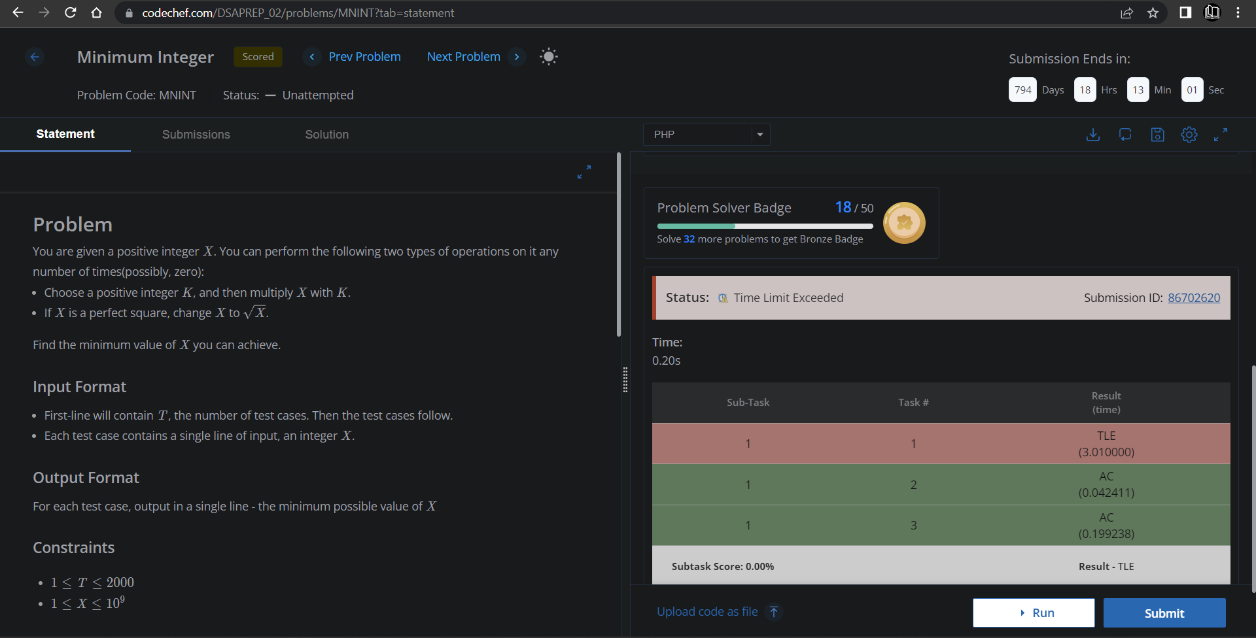

**Understanding about problem:**

Note: If you can't understand the problem, feel free to contact us and we'll help you. Please don't copy and paste from anywhere.

ALL THE BEST

Team CP Club